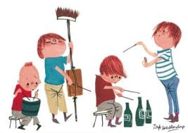

***Muziekactiviteit groep 1 en 2.***

***Schooljaar 2019-2020***

*Thuis gezellig zingen met opa Ruud.*



Almost heaven, West Virginia  
Blue Ridge Mountains, Shenandoah River  
Life is old there, older than the trees  
Younger than the mountains, growing like a breeze

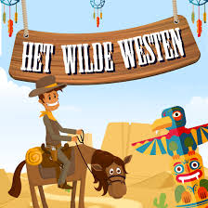Country roads, take me home  
To the place I belong  
West Virginia, mountain mama   
Take me home, country roads

